

How to Navigate The DICE Approach™ Website
This guide helps general users navigate The DICE Approach™ training website (https://diceapproach.com). It includes instructions for accessing the Signup, Training, and Contact sections, and how to activate closed captioning in training modules. Screenshots are included for visual reference.

1. Signup Page
To sign up for training or updates, look for the ‘Sign Up' button in the top menu or homepage. Follow the prompts to create an account – it is free.
- SIGNUP: Click on SIGNUPO and you will be taken to a page to enter your email address (will not be made public or shared), create a username and password. You will also be able to enter the name of the caregiver and whether you are a home/family caregiver or a professional caregiver. This is for a future feature and is optional.
- After you’ve signed up you can use the LOG IN tab to access the videos and benefits of the training website.

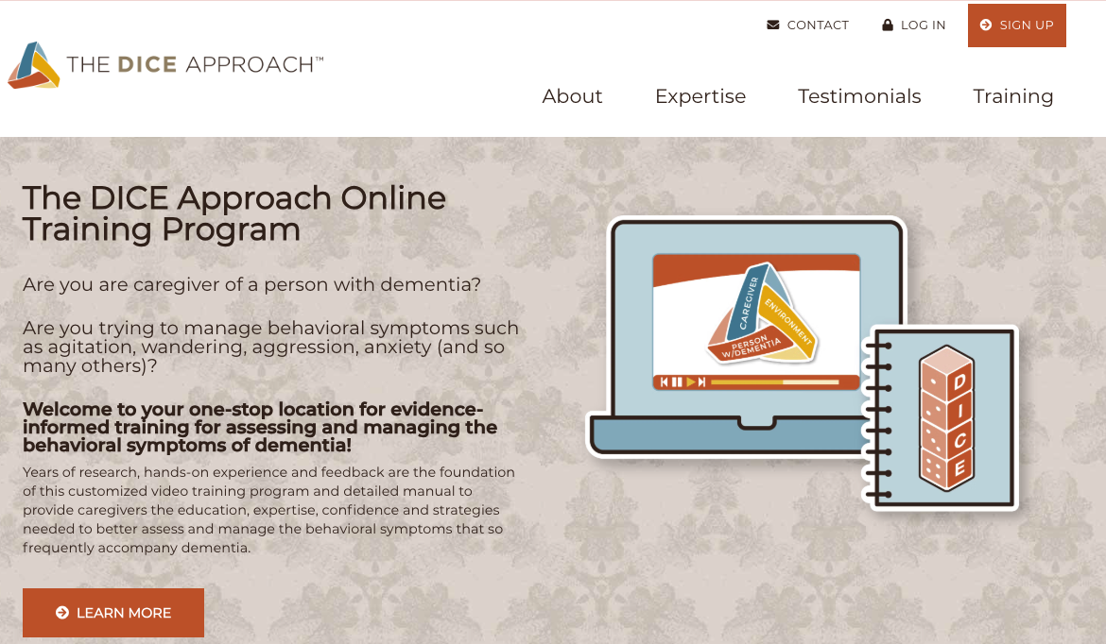

2. Homepage
When you visit https://diceapproach.com, you’ll land on the homepage. This page introduces the DICE Approach and provides access to all major sections via the top navigation bar.
Click on the navigation item you desire….

3. Training Tab
Once you have signed up, you have access to the training modules. Click on the 'Training'’ tab and you will be taken to the video modules, including the family and professional case studies that include informational quizzes for learning.

4. Contact Form
Use the 'Contact' tab to reach out to the DICE team. Fill out the form with your name, email, and message. We promise to get back to you promptly!

5. Closed Captioning in Training Modules, Chapters and selecting Closed Captioning language
When watching training videos, look for a 'CC' or 'Subtitles' button on the video player. Click it to enable closed captioning for better accessibility.
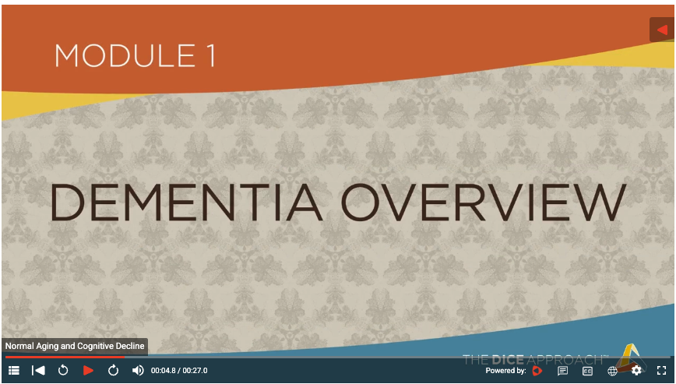
4
2 3 4 5
1

- CHAPTERS: Each module has chapters, and you can access any chapter you desire by clicking on the button and then the chapter you want to jump to.
- TRANSCRIPT: You can follow along with a transcript by clicking this button.
- CLOSED CAPTIONING: You can turn Closed Captioning on or off by using this button. You can also select the language you desire to use for the Closed Captioning. If you do not see your desired language, please let us know and we will do our best to add it
- CHAPTER TITLE: This button allows you to see the chapter you are viewing.
- SETTINGS: Here, you can adjust the speed of the video and the HD quality.

Use The DICE Approach™ worksheet to track and evaluate your DICE caregiving activities with this printable, comprehensive tool that can be downloaded! Click on the link shown by the arrow below.
It is located on the Training Modules page between the training modules and the E-Sim videos.

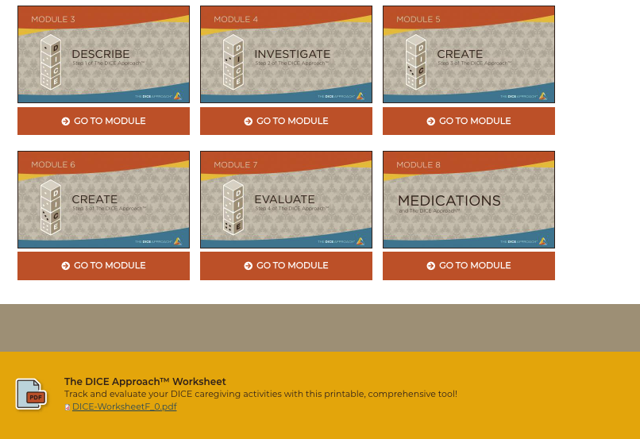

The DICE Approach team honors you and your caregiving mission and are grateful to provide this training website to assist you. Please don’t hesitate to reach out via the contact form if you have any questions about the site or need assistance. Please note that we cannot provide medical guidance.

